Committee: The Security Council

The Question of: Addressing the Security Transition and Regional Crises in Somalia (The recognition of Somaliland)

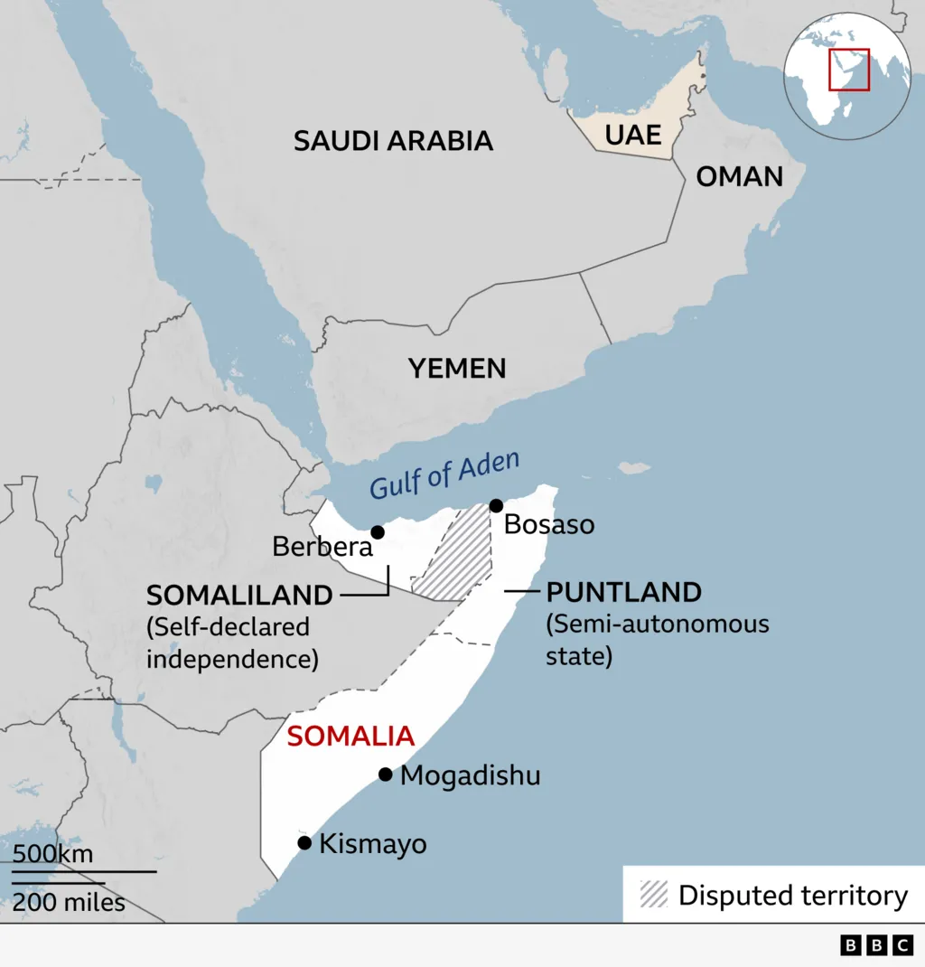
Introduction
Somaliland, a self-declared independent state in the Horn of Africa, gained its first de jure recognition from a UN member state, Israel, on December 26, 2025, ending decades of international impasse, though Somalia still claims it as its territory. This recognition followed Somaliland's consistent operation with its own government and institutions since declaring independence in 1991, but it has faced significant pushback from Somalia and concerns over African territorial integrity, with many analysts predicting few other nations will follow Israel's move due to geopolitical complexities.

Key terms

Somaliland: historically, the area now comprising Somalia and Djibouti. The name is also used to refer to the Republic of Somaliland, a self-declared independent country in the Horn of Africa that has its capital at Hargeisa.
Protectorate: the position or period of office of a Protector, especially that in England of Oliver and Richard Cromwell.
Memorandum of Understanding: a formal, often non-binding, document between two or more parties that outlines their shared goals, intentions, and responsibilities for a collaboration, serving as a preliminary step or framework before a legally binding contract is established.
2020 Abraham Accords: a series of US-brokered normalization agreements between Israel, the United Arab Emirates (UAE), and Bahrain, later joined by Morocco and Sudan, establishing full diplomatic relations and fostering economic, security, and cultural ties, built on shared concerns about Iran and opportunities for regional cooperation.

Leading up to the Issue
After the conclusion of treaties between Great Britain and the various Somaliland clans in the early 1880s, the Somaliland Protectorate was proclaimed in 1887. The international boundaries of the Protectorate were delineated by treaties with France (Djibouti) to the west in 1888, Ethiopia to the south in 1887 and Italy (Somalia) to the east in 1894.

Following the civil war that began in Somalia in the 1980s and the subsequent overthrow of that country’s government in 1991 and the collapse of Somali ruler Siad Barre's military regime, the Somali National Movement, secured the region comprising the former British Somaliland. In May 1991 they announced that the 1960 federation was no longer valid and declared their region to be an independent state, henceforth to be known as the Republic of Somaliland. Though it was not internationally recognized, Somaliland experienced relative stability—a sharp contrast to the civil war that continued to engulf Somalia. Taking advantage of that stability, in the following years the Somaliland government was able to rebuild much of the region’s infrastructure, which had been damaged by years of warfare, and established its own currency and flag.

In 2001, 10 years after breaking away from Somalia, Somaliland still was not internationally recognized as an independent country. Undeterred, the government held a referendum that year, the results of which clearly showed that Somaliland’s inhabitants supported the region’s claim of independence. As it had in the past, in 2003 the Somaliland government rejected invitations to participate in peace talks aimed at reunifying Somalia, maintaining that its independent status precluded it from being a party to such discussions.

Recent Events
In December 2025 Israel became the first country to recognize the Republic of Somaliland as an independent country and established diplomatic relations with it. The move was met with strong condemnation from Somalia’s government, which called it an attack on its sovereignty; other countries and international organizations, such as the African Union and the Organization of Islamic Cooperation, also criticized the development and affirmed their support for Somalia’s sovereignty and territorial integrity.

In exchange, Somaliland said it would sign up to the 2020 Abraham Accords, which have so far seen the UAE, Bahrain and Morocco establish full diplomatic relations with Israel, giving Prime Minister Benjamin Netanyahu's government a boost at a time it has faced a backlash over the war in Gaza.

Somaliland’s leaders hailed Israel’s decision as “historic,” celebrating it as long-awaited validation of de facto statehood, with the Israeli flag projected in Somaliland’s capital, Hargeisa. The decision builds on Somaliland’s record of relative stability and functioning democratic institutions, factors that have long differentiated it within a volatile region. However, beyond its symbolism, the significance of recognition will be shaped by its implementation. How Israel translates this decision into security, economic, and diplomatic engagement, while managing regional sensitivities and coordinating with key partners, particularly the United States and the United Arab Emirates (UAE), will determine whether recognition evolves into a durable framework for regional cooperation.

Recognition does not resolve Somaliland’s contested international status. The Somali Federal Government considers Somaliland part of its territory and opposes any foreign engagement implying recognition. Israel remains the sole United Nations member to have taken this step. The United States, European Union, African Union (AU) members, and even Somaliland’s closest regional partner, the United Arab Emirates, have thus far refrained from recognition. The AU has rejected Israel’s move, reaffirming its commitment to Somalia’s territorial integrity and limiting Somaliland’s access to international institutions in the near term.

Israel's announcement followed a controversial January 2024 Memorandum of Understanding between Ethiopia and Somaliland, which proposed Ethiopian access to the Red Sea through a port and naval base in exchange for potential recognition. The deal was later renegotiated after sparking strong opposition from Somalia.

The Effect
- On Somalia:
As Somalia views this recognition as a breach of sovereignty, Somalia's government has won the backing of key countries across Africa and the Middle East through diplomatic outreach and high-level phone calls, rallying them to oppose the recognition. But one relationship has sharply deteriorated - Somalia's long-standing partnership with the United Arab Emirates (UAE), which has been viewed as a significant player in Somalia's security, economy, and politics, as the country has a coastline of more than 3,000km (1,864 miles) along the Gulf of Aden and the Indian Ocean - a strategic maritime region hit by piracy and weapon-smuggling that has contributed to instability in both Africa and the Middle East.
In addition, Somalia and its allies see the move as a national security threat. Protests are also on the rise in Somalia.

- On Africa:
The recognition could embolden secessionist movements across Africa, including in Western Sahara, Senegal, Nigeria, the Democratic Republic of Congo (DRC) and Sudan. Moreover, unilateral decisions risk further destabilizing an already fragile region.

- On the Red Sea:
Israeli officials have confirmed that the recognition is linked to countering Iran and its regional proxies, particularly the Houthi rebels in Yemen. Somaliland’s leadership has, according to regional reporting, been open to hosting an Israeli security presence in exchange for recognition. Formal ties now allow for open discussions on intelligence sharing, port security, and, over time, potential logistical or monitoring arrangements aimed at Red Sea threats.

Regional responses
So far, many of Somaliland's neighbours have reacted cautiously or remained silent. Security and geopolitical analyst Fidel Amakye Owusu noted that Ethiopia, which has long enjoyed close ties with Israel, is unlikely to openly condemn the move. However, Kenya and the broader African Union see the decision as inconsistent with Africa's long-standing opposition to the recognition of breakaway territories.

Works cited:
https://www.dw.com/en/israels-somaliland-recognition-strategic-ripples-in-africa/a-75590942#:~:text=Nontokozo%20Mchunu%20%7C%20Adwoa%20Tenkoramaa%20Domena,and%20a%20separate%2C%20stable%20state.
https://www.bbc.com/news/articles/c99k4jxz0ndo
https://www.atlanticcouncil.org/blogs/menasource/after-israels-recognition-of-somaliland-what-comes-next/
https://www.britannica.com/place/Somaliland

