Immigration and customs enforcement, unlawful arrests and abuse of power in USA

The USA has proven itself to be one of the most influential and powerful countries worldwide time and time again; its sovereignty has fortifiable manpower and constantly strives to improve the state of the country and general population, regardless of the effect it has on other countries. This inherently provides the citizens of the country with a sense of security and access to an endless supply of opportunities; subsequently, many individuals fleeing from harsh or inhumane conditions consider the USA a top choice to support their lives.
That being said, many individuals tend immigrate to the USA without undergoing the proper procedure to become authorized, this being done through a number of different ways; e.g. by entering the country with a visa allowing them to stay for a limited amount of time, then remaining in the country after the visa expires, or entering the country legally from Mexico using a Border Crossing Card, a document that allows short visits limited to the border region, and then violating the terms of admission. Other individuals from the unauthorized migrant population entered the country illegally by hiding to avoid customs and immigration inspections at ports of entry.

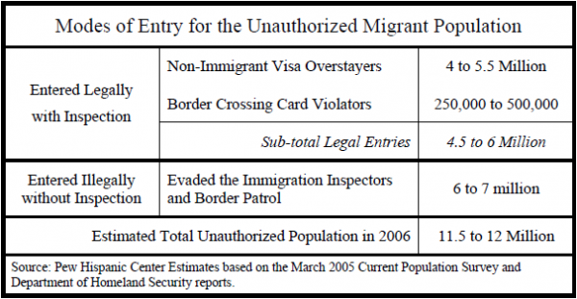

Considering additional information regarding the mode of entry of unauthorized migrants, it’s estimated that the annual flow of new unauthorized migrants is almost evenly divided between those who enter legally and those who do not.

Regarding the overstays through which individuals become unauthorized migrants, A 2003 report by the U.S. Government Accountability Office (GAO) found “there is no accurate list of overstays” because not all departure forms are collected and not all can be matched to arrival forms. In effect, the government has a pretty good idea of how many people come into the country if they fill out one of the forms, but it does not have a full count of how many leave.

Regarding the abuse of the Border Crossing Card; there is little hard data on which to base estimates of the number of unauthorized migrants who entered the country by using a Border Crossing Card. But, given that the traffic is so enormous, an estimated 148 million entries in 2004—if even a minuscule share of these individuals overstayed, they would contribute significantly to the unauthorized population.
Starting in 1998, a new credit-card style document with a biometric identifier such as a fingerprint was issued for regular border crossers. Between 1998 and the 2001 deadline for the replacement of old cards, the Department of State issued more than 4 million of the new cards to Mexican nationals. These authorize visits of up to 30 days within a border zone of 25 miles along the border in California, Texas and New Mexico and 75 miles of the border in Arizona. Cardholders who want to travel further or stay longer must apply for an exception and file an I-94 form. Cardholders can easily overstay their visits since, unlike with I-94 forms, there is no attempt to check on whether the border crossers leave. Moreover, border crossing cards have been used fraudulently by others to cross because the biometric identifiers are not checked for all border crossers or at all ports of entry.

Article 1, § 8, clause 4, of the United States Constitution specifically grants Congress the power to establish a "uniform Rule of Naturalization." By expressly allocating this power to Congress, the Constitution prevents the confusion that would result if individual states could bestow citizenship.
Hence, the supreme court has historically given Congress broad authority over immigration.
Unauthorized immigrants in the USA violate federal statuary law regarding immigration, specifically through unlawful entries or overstaying visas. HOWEVER, these are generally considered federal civil or criminal infarctions, rather than violations of the US constitution itself. This is really important to take into consideration, because unlawful immigration is not a violation of the constitutional laws of immigration, but using force in order to execute punishment of illegal immigration is in fact a violation of the constitutional law.
The Fifth Amendment states:
“No person shall be… deprived of life, liberty, or property, without due process of law.”
The Fourteenth Amendment guarantees:
“Nor shall any State deprive any person of life, liberty, or property, without due process of law; nor deny to any person… the equal protection of the laws.”

Before getting reelected as president in 2025, Donald Trump pledged to put an end to the ongoing case of illegal immigration at the time, calling it “the largest domestic deportation operation in American history”
His administration executed that promise, deporting more than half a million people in 2025. However, it’s continuously dawning on people that the methods through which his orders are executed are violent and gruesome. People have died as a result of the aggression of the immigration agents, homes of the illegal immigrants have been broken into, not to mention the retaliation they are faced with whenever they film the agents breaking their constitutional rights.
Undocumented immigrants in the USA have several key rights, including;
The right to a hearing before deportation;
The right to apply for asylum or other forms of protection;
The right to be represented by legal counsel at their own expense;
The right to challenge unlawful government actions;
Protection against indefinite detention.
The inconsistency between the rights of illegal immigrants (stated above) and the way in which the Immigration and Customs Enforcement (ICE) has handled the deportation of immigrants is very clear.
Further documented assaults/ coercion to live in inhumane conditions in immigration detention:
- Each pod holds 60–70 people who report chronic food shortages, with meals sufficient for only about 50 individuals. People are forced to ration food, skip meals, or take turns eating — and when food is available, it is often spoiled or partially frozen, causing widespread vomiting, diarrhea, and rapid weight loss.
- Individuals with serious conditions report going days or weeks without prescribed medication or having medical requests ignored until someone collapses.
- Extreme and unlawful use of force is also prominent at Fort Bliss (immigration detention). Several detained individuals have described violent assaults by officers, including sexual abuse.
- Access to counsel and legal services is similarly inadequate. When Fort Bliss (immigration detention) opened, it relied almost entirely on tablets for visitation and attorney communication, offering no privacy for confidential legal calls.

In closing, the sovereignty of the USA has the right to have standards for who is awarded citizenship and who isn’t, as a measure to protect the citizens of the country and maintain security. Nonetheless, the way in which is law is carried out is incredibly violent and shows discrepancy in regards to the laws.

Citations;
- https://www.pewresearch.org/

- the-birth-of-illegal-immigration

- immigrationlaw/chapter2

- https://www.theusconstitution.org

- constitutional-rights-of--undocumented-immigrants

- immigrants-rights/detained-immigrants-detail-physical-abuse

- immigration-and-customs-enforcement ( detailed ICE- immigration and customs enforcement supposed goals )

